Name:_____________________________________________________________________________________________
Sociology Then and Now
Chapter 1- Section 2: Page 9-17
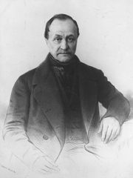  - _____________ | 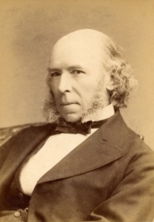  - _____________ | 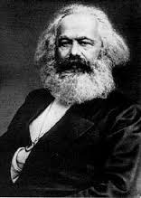  - _____________ | 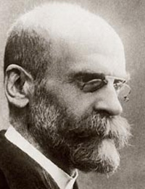  - _____________ | 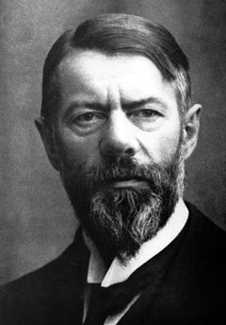  - ______________
Topics of Interest: | Topics of Interest: | Topics of Interest: | Topics of Interest: | Topics of Interest:

- ______________Perspective | 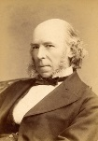  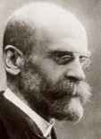 | DEFINITION:
- ______________Perspective |  | DEFINITION:
- ______________Perspective | 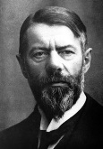 | DEFINITION:
- Read page 15. Focus on the section titled “Applying the Skill.” Note how the passage describes a potential study of Changes in the Media and Positive Minority Role Models. (The picture at the top of 15 shows Desi Arnaz from the I Love Lucy television show from the 1950’s) describe below how a potential researcher would view the subject of Minorities in Media differently whether he/she were a Functionalist, Conflict Theorist, or Interactionist (HINT: #4) .

--FUNCTIONALIST:

--CONFLICT THEORIST:
--INTERACTIONIST:

-Which approach did the researcher choose and why?

- Choose one of the 3 issues from page 3 (Technology, Marriage, or Crime) and explain how a researcher would view that issue from the Functionalist Perspective. Conflict Theory? Interactionist? (Try to use at least 1 or 2 supporting vocab words)
ISSUE FROM PAGE 2:___________________________

--FUNCTIONALIST:

--CONFLICT THEORIST:

--INTERACTIONIST:

