Background on the Cuban Missile Crisis
The Cuban Missile Crisis was a pivotal moment in the Cold War. Fifty years ago the United States and the Soviet Union stood closer to Armageddon than at any other moment in history. In October 1962 President John F. Kennedy was informed of a U-2 spy-plane’s discovery of Soviet nuclear-tipped missiles in Cuba. The President resolved immediately that this could not stand. Over an intense 13 days, he and his Soviet counterpart Nikita Khrushchev confronted each other “eyeball to eyeball,” each with the power of mutual destruction. A war would have meant the deaths of 100 million Americans and more than 100 million Russians.
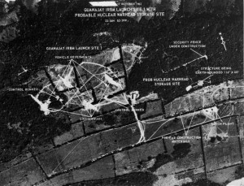
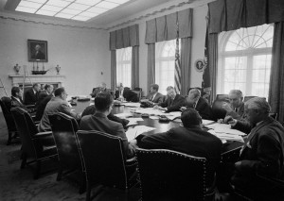
Pausing at the nuclear precipice, President Kennedy and the group of advisors he had assembled (known as ExComm) evaluated a number of options. After a week of secret deliberations, he announced the discovery to the world and imposed a naval blockade on further shipments of armaments to Cuba. A tense second week followed, during which neither side backed down. Presented with the choice of attacking or accepting Soviet nuclear missiles in Cuba, Kennedy rejected both options. Instead, he crafted an alternative with three components: a public deal in which the United States pledged not to invade Cuba if the Soviet Union withdrew its missiles; a private ultimatum threatening to attack Cuba within 24 hours if the offer was rejected; and a secret sweetener that promised to withdraw U.S. missiles from Turkey within six months. The crisis was resolved at the last minute when Khrushchev accepted the U.S. offer.
Meeting of the Executive Committee of the National Security Council. October, 29 1962. (ExComm)

October 17, 1962: U-2 photograph of first IRBM site found under construction

LEADER | WHO ARE THEY?--------------WHAT DID THEY DO?
PRESIDENT JOHN F. KENNEDY | Soon after taking office in 1961, he authorized the “Bay of Pigs” invasion led by the CIA and exiles from Cuba, whose government had been overthrown by communist rebels in 1959. This failed to overthrow leader Fidel Castro, and was a major embarrassment to Kennedy. Tensions with the Soviet Union further escalated during the 1961 Berlin Crisis. These events set the stage for the Cuban Missile Crisis. On October 15, 1962 Kennedy was informed of the discovery of Soviet missiles in Cuba and called a meeting of a small circle of trusted advisors (known as the Executive Committee of the National Security Council, or ExComm).
SOVIET PREMIER NIKITA KHRUSHCHEV  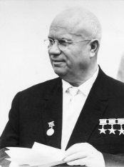 | Khrushchev became First Secretary of the Communist Party of the Soviet Union in 1953 after a power struggle following Stalin’s death, and served as Premier from 1958 to 1964. Khrushchev began efforts to “de-Stalinize” Soviet society. However, in 1961 tensions between the superpowers escalated over the Berlin Crisis. In the spring of 1962 Khrushchev made the decision to place Soviet missiles in Cuba secretly in order to give a quick boost to Soviet missile power, and to strengthen the USSR’s bargaining position regarding the Berlin question.
PRIME MINISTER OF CUBA FIDEL CASTRO | In January 1959 Fidel Castro’s revolutionary forces seized power. While the Cuban leader initially claimed this was not a communist revolution, a year later Cuba formally aligned itself with the Soviet Union. Relations with the United States deteriorated further in 1961when the U.S. supported CIA-trained anti-Castro exiles in the Bay of Pigs invasion – a failed attempt to overthrow Castro and a major blow for President Kennedy. In this context, in the summer of 1962 Castro accepted the Soviet offer to install missiles in Cuba as a deterrent to a U.S. invasion. During the crisis Castro urged Khrushchev to defend Cuba and reject American demands to withdraw the missiles. On October 27, believing a U.S. attack was imminent, Castro urged Khrushchev to initiate a nuclear first strike.
EXCOMM ADVISORS | - Under Secretary of State George Ball  - National Security Adviser McGeorge Bundy  - Secretary of the Treasury C. Douglas Dillon  - Deputy Secretary of Defense Roswell Gilpatric  - Vice President Lyndon Johnson  - Attorney General Robert Kennedy | - CIA Director John McCone  - Secretary of Defense Robert McNamara  - State policy planner Walt Rostow  - Secretary of State Dean Rusk  - Special Counsel Theodore Sorensen  - Chairman of the Joint Chiefs of Staff General Maxwell Taylor  - Ambassador at Large for Soviet Affairs Llewellyn “Tommy” Thompson
Important American Personnel that were NOT on EXCOMM | - Former Secretary of State Dean Acheson  - Ambassador Charles ‘Chip’ Bohlen  - Air Force Chief of Staff Curtis LeMay  - Special Assistant to the President Kenneth O’Donnell  - UN Ambassador Adlai Stevenson
Soviet Personnel Involved with the Crisis | - Ambassador Alexander Alexeev  - Ambassador Anatoly Dobrynin  - Foreign Minister Andrei Gromyko  - UN Representative Valerian Zorin

