Battles Loom in Many States Over What to Do With Budget Surpluses
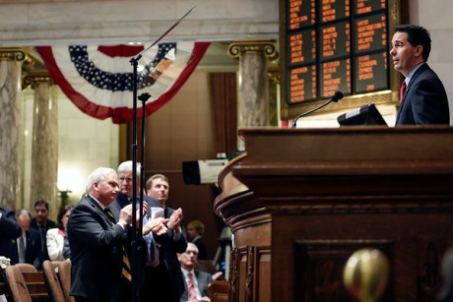
By RICK LYMANFEB. 2, 2014
In a year when three dozen governors are up for election, unexpectedly robust revenues from taxes and other sources are filling most state coffers, creating surpluses not seen in years and prompting statehouse battles over what to do with the money.
After so many years of sluggish revenues, layoffs and draconian service cuts, governors and legislators are eager to use the newfound money to cut taxes, restore spending or, in some cases, pay down debts or replenish rainy-day funds for future recessions. But though revenues are improving, lawmakers are likely to find that there is not enough to pay for everything they want to do, experts say.
“The states are going to have what seems like extra money,” said Scott D. Pattison, executive director of the National Association of State Budget Officers. “Expectations will be high, but the money is not going to be enough to satisfy everyone’s expectations.”
While Republicans are tending to advocate more tax cuts and Democrats are more often pushing to restore spending on education and other programs, the differences between the two camps are not always so stark, with some governors outlining plans that appeal across party lines.
Joining Republican anti-tax stalwarts like Dave Heineman of Nebraska and Scott Walker of Wisconsin in calling for more tax cuts, for instance, is a Democrat, Gov. Andrew M. Cuomo of New York.
And while Democratic governors like Jay Nixon of Missouri and John W. Hickenlooper of Colorado are pushing for significantly more education spending, so are Republican governors in Kansas, Georgia and Idaho, among others.
In Kansas, Gov. Sam Brownback, among the most conservative, is calling for full-day kindergarten for all students. In her State of the State address, Gov. Susana Martinez of New Mexico, a Republican, talked about increasing teacher salaries.
“Next to their parents, the adults children see most in their life are their teachers,” Governor Martinez said. “We should support our teachers with additional pay.”
Still, Ms. Martinez’s view was not shared by her fellow Republicans in Missouri, where Republican legislators sharply criticized Governor Nixon’s proposal to increase education spending by $493 million. “It is really unfortunate that this governor’s only solution is to throw money at problems,” said Tim Jones, the speaker of the Missouri House.
In some states where one party controls both the governor’s seat and the legislature, intraparty battles are looming over how to use the surpluses.
One example is in California, where Gov. Jerry Brown, a Democrat, called in his State of the State address for more money to go into a rainy-day fund rather than into renewed spending — over the loud objections of some Democratic legislators who want to restore more of what had been trimmed in recent years.
“For a decade, budget instability was the order of the day,” Mr. Brown said. “A lethal combination of national recessions, improvident tax cuts and too much spending created a financial sinkhole that defied every effort to climb out.”
Darrell Steinberg, the Senate president pro tem and a fellow Democrat, shot back, saying that while putting some money into the rainy-day fund was laudable, the governor’s plan shortchanged crucial needs. “We must invest in the people of California, especially those living in the economic margins,” he said. “I’ve proposed and remain committed to a balanced framework of ‘a third, a third, a third,’ where we divide the surplus into reserves, repayment and reinvestment.”
Jostling among Republicans over how to spend the surpluses is also underway in Michigan, where Gov. Rick Snyder, a conservative Republican, announced a $791 million budget surplus and called for additional spending on education and infrastructure, as well as tax cuts. In response, the Republican-dominated Senate Finance Committee approved a bill that put specific numbers on the governor’s proposal, cutting the state’s income tax from 4.25 percent to 3.9 percent by 2017.
States are seeing these surpluses because early projections by their budget officers are proving to have been too conservative. An overall strong year for the stock market and a general economic uptick are generating more income, property and sales tax revenues than expected. At the same time, a milestone is about to be reached: In the coming months, budget officials expect that state revenues will climb back to their pre-recession level, even accounting for inflation.
The result: Optimism about digging out of the recession is occurring at the same moment surpluses are landing. But many experts in state finances say governors and legislatures may be too eager to spend the new money rather than paying down debt, bolstering shaky pension systems or setting aside money for the next downturn.
States got a taste of improved revenues last year, when estimates of how many investors would sell holdings by the end of 2012 to avoid new tax regulations proved too low — leading to a sharp rise in state revenues, 5.7 percent nationwide.
Fearing that this had been an isolated bump, most states again were very conservative in their revenue estimates for the current fiscal year. Now that actual revenues are being collected, the projections are turning out to be low.
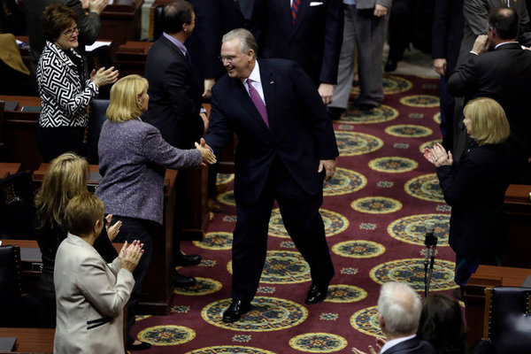
“It seems that the bump was not just a one-time bump,” said Eileen Norcross, a senior research fellow at the Mercatus Center at George Mason University in Virginia, who specializes in state and local finances. “The rate of growth in 2014 for revenues was slower than in 2013, but still significant.”
With memories of recent deficit struggles still fresh in their minds, many governors are joining Mr. Brown in talking about putting at least some money into rainy-day funds, including governors in Michigan, Colorado and Hawaii, among others.
And while several governors, including Gov. Chris Christie of New Jersey, have called for more attention to state pension debt, few have yet to offer specifics. One exception was Gov. Sean Parnell of Alaska, a Republican, who wants to transfer $3 billion from state reserves for the state’s pension system.
There has also been ample talk in legislatures this month about infrastructure, much of it fairly vague but some aimed at specific projects. This is a sizable switch from recent years, when borrowing for large capital projects like bridges and highways had all but vanished amid budget shortfalls.
“With huge pressure to deal with some of these infrastructure issues, I think you will see that getting more attention in the coming months,” said Mr. Pattison of the budget officers association.
Still, state officials and analysts caution that trying to gauge the outcome of a legislative session by a governor’s opening address can be foolhardy. Political give-and-take, as usual, will shape the outcomes.
“I actually think most states, if they look pretty honestly at it, would have a hard time making a case for big new tax cuts or big new expenditures,” said Nicholas Johnson, vice president for state fiscal policy at the Center on Budget and Policy Priorities.
“Managing ongoing services and undoing some of the worst things done during the recession will account for all or more than all of the revenue growth out there,” he said. “We are going up, but we are not free and clear yet.”

