Does Your School Seem Integrated?
By Michael Gonchar
May 20, 2014 5:00 am
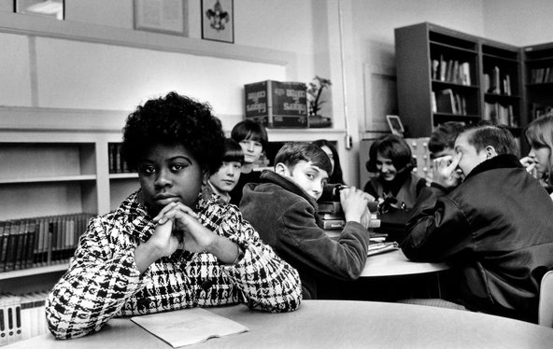
Linda Brown Smith, in an undated photograph, was a third grader when her father began a class-action lawsuit that led to the Supreme Court’s 1954 decision against school segregation.
While last weekend was the 60th anniversary of the Supreme Court decision Brown v. Board of Education that ended legal segregation in public schools, the federal Department of Education just released a statement announcing that de facto segregation is very much alive.
Does your school feel integrated? Is de facto segregation — segregation that occurs not because of laws, but for other complex reasons — still alive in your community?
In the article “Michelle Obama Cites View of Growing Segregation,” Sheryl Gay Stolberg writes about Mrs. Obama’s speech delivered to high school seniors in Topeka, Kan., last Friday:
Sixty years after the Supreme Court outlawed “separate but equal” schools for blacks and whites, civil rights advocates say American schools are becoming increasingly segregated, while the first lady, Michelle Obama, lamented that “many young people are going to schools with kids who look just like them.”
“Today, by some measures, our schools are as segregated as they were back when Dr. King gave his final speech,” Mrs. Obama told 1,200 graduating high school seniors Friday here in the city that gave rise to the landmark Brown v. Board of Education case.
In a speech that was part commencement address, part policy pronouncement and part journey into her own past, Mrs. Obama said that Brown’s advances were being reversed. “Many districts in this country have actually pulled back on efforts to integrate their schools, and many communities have become less diverse,” she said, leading to schools that are less diverse.
“And too often,” Mrs. Obama said, “those schools aren’t equal, especially ones attended by students of color which too often lag behind.”
Today about four in 10 black and Latino students attend intensely segregated schools, the federal Department of Education reported on its official blog on Friday, adding that only 14 percent of white students attend schools that could be considered multicultural.
“We have slowly and very steadily slipped backward,” said Catherine E. Lhamon, the department’s assistant secretary for civil rights. “All over the country we are seeing more and more racially segregated schools.”
Students: Read the entire article, then tell us …
- Does your school feel integrated? Is de facto segregation — segregation that occurs not because of laws, but for other complex reasons — still alive in your community?
- Does your school have a mix of students with different racial backgrounds? Is there any group that feels missing or underrepresented based on the makeup of your city or town?
- Do students with different racial or ethnic backgrounds socialize together in your school? For example, does your lunchroom feel integrated? Do social clubs and sports teams seem integrated?
- How do you think the United States can make its schools more integrated and less segregated?

