How Much Does Your Neighborhood Define Who You Are?
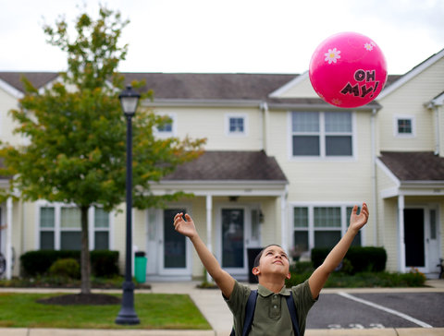
Does your neighborhood shape who you are? Would you be a different person if you grew up someplace else?

According to a recent Op-Ed article, where you live “profoundly shapes who you are.” In
“Here Comes the Neighborhood,” David L. Kirp comments on the results of a study about affordable housing in an affluent suburban community. He argues that having the opportunity to live in a peaceful neighborhood with good schools can transform lives.

Suburbia beckons many poor and working-class families with the promise of better schools, access to non-dead-end jobs and sanctuary from the looming threat of urban violence. But many suburbanites balk at the prospect of affordable housing in their midst.
They fear that when poor people move next door crime, drugs, blight, bad public schools and higher taxes inevitably follow. They worry that the value of their homes will fall and the image of their town will suffer. It does not help that the poor are disproportionately black and Latino. The added racial element adds to the opposition that often emerges in response to initiatives designed to help poor families move to suburbs from inner cities.
Are the fears supported by facts? A comprehensive new analysis of what has transpired in Mount Laurel, N.J., since 140 units of affordable housing were built in that verdant suburb in 2000, answers with a resounding “no.”

Where you live profoundly shapes who you are. “I would go as far as to argue that what is truly American is not so much the individual but neighborhood inequality,” concludes the Harvard sociologist Robert J. Sampson in his landmark 2012 book, “Great American City.” The families that migrated to Mount Laurel — earning from 10 to 60 percent of median income — obtained more than a nicer house. They secured a new lease on life, a pathway out of poverty for the adults and a solid education for the children.
- How much does your neighborhood define who you are? Discuss ways that your neighborhood shapes your identity.
- Would you be a different person if you grew up someplace else? Explain.
- Imagine some ways your life might be different if you lived in another kind of neighborhood — for example, if it was more peaceful or crime-ridden, with better or worse schools, depending on your circumstances.

