WEEK 2 CASE STUDY

Is Your Generation Really ‘Postracial’?
By Katherine Schulten
February 26, 2014
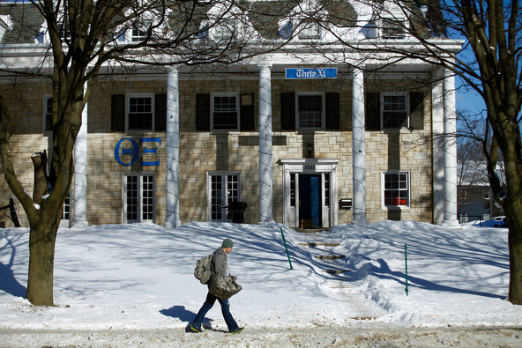
In November, the Theta Xi fraternity at the University of Michigan planned a party called “World Star Hip Hop: Hood Ratchet Thursday,” and invited “rappers, twerkers, gangsters” and others “back to da hood again.” The fraternity, which is mostly white and Asian, later canceled the party in response to protests. Similar episodes have unsettled students at colleges including Arizona State, the University of Mississippi, Dartmouth and the University of California, Los Angeles.

According to Urban Dictionary, “postracial” is “a term used to describe a society or time period in which discussions around race and racism have been deemed no longer relevant to current social dynamics. Popularized after the election of Barack Obama to the presidency of the United States of America in 2009.”
How “postracial” is your school or community, in your opinion? Our society as a whole? Do you agree with a recent Times article that says, though many believe that millennials are growing up in a colorblind society, “racial tensions are playing out in new ways among young adults”?
Why or why not?
In “Colorblind Notion Aside, Colleges Grapple With Racial Tension,” Tanzina Vega writes:
A brochure for the University of Michigan features a vision of multicultural harmony, with a group of students from different racial backgrounds sitting on a verdant lawn, smiling and conversing.
The scene at the undergraduate library one night last week was quite different, as hundreds of students and faculty members gathered for a 12-hour “speak out” to address racial tensions brought to the fore by a party that had been planned for November and then canceled amid protests. The fraternity hosting the party, whose members are mostly Asian and white, had invited “rappers, twerkers, gangsters” and others “back to da hood again.”
Beyond the immediate provocation of the party, a sharp decline in black undergraduate enrollment — to 4.6 percent of the student body in 2013 from 6.2 percent in 2009 — and a general feeling of isolation among black students on campus have prompted a new wave of student activism, including a social media campaign called “Being Black at the University of Michigan” (or, on Twitter, #BBUM). Members of the university’s Black Student Union have petitioned campus administrators to, among other things, increase enrollment of black students to 10 percent.
Similar episodes and tensions have unsettled colleges including Arizona State; the University of California, Los Angeles; the University of Mississippi; and Dartmouth.
In the news media and in popular culture, the notion persists that millennials — born after the overt racial debates and divisions that shaped their parents’ lives — are growing up in a colorblind society in which interracial friendships and marriages are commonplace and racism is largely a relic.
But interviews with dozens of students, professors and administrators at the University of Michigan and elsewhere indicate that the reality is far more complicated, and that racial tensions are playing out in new ways among young adults.
Some experts say the concept of being “postracial” can mean replicating some of the divisions and insensitivity of the past, perhaps more from ignorance than from animus. Others find offensive the idea of a society that strips away deeply personal beliefs surrounding self-identification.
“There’s this preconceived notion that our generation is postracial, but there’s these incidents that happen constantly that disprove that point,” said Zach Fields, a business major here, who is white. He attributed many high-profile incidents — including a number of fraternity parties nationwide that have used racist symbols, including watermelons and gang signs — to ignorance.
“I feel like they don’t mean to be so offensive,” Mr. Fields, 20, said of the party organizers. “It’s not a conscious racism. It’s subconscious.”
Students: Read the entire article, then tell us …
— Are there racial tensions, whether overt or subtle, in your school or community? If so, how would you describe them?
— Is your generation “postracial”? Do you think media and popular culture have it wrong when they characterize millennials this way, or do you think there is an element of truth in that description? Why or why not?
— Do you agree with Tiya A. Miles, chairwoman of the department of Afro-American and African studies at the University of Michigan, who says it’s possible that “having a black president lets people feel like that gives them cover. It absolves people of being prejudiced”?
— How openly is the topic of race addressed in your school? In your community? If you’re not satisfied with the status quo, how do you wish the topic were addressed? Why?

