WEEK 2 CASE STUDY REFERENCE ARTICLE
Colorblind Notion Aside, Colleges Grapple with Racial Tension
By TANZINA VEGAFEB. 24, 2014
ANN ARBOR, Mich. — A brochure for the University of Michigan features a vision of multicultural harmony, with a group of students from different racial backgrounds sitting on a verdant lawn, smiling and conversing.
The scene at the undergraduate library one night last week was quite different, as hundreds of students and faculty members gathered for a 12-hour “speak out” to address racial tensions brought to the fore by a party that had been planned for November and then canceled amid protests. The fraternity hosting the party, whose members are mostly Asian and white, had invited “rappers, twerkers, gangsters” and others “back to da hood again.”
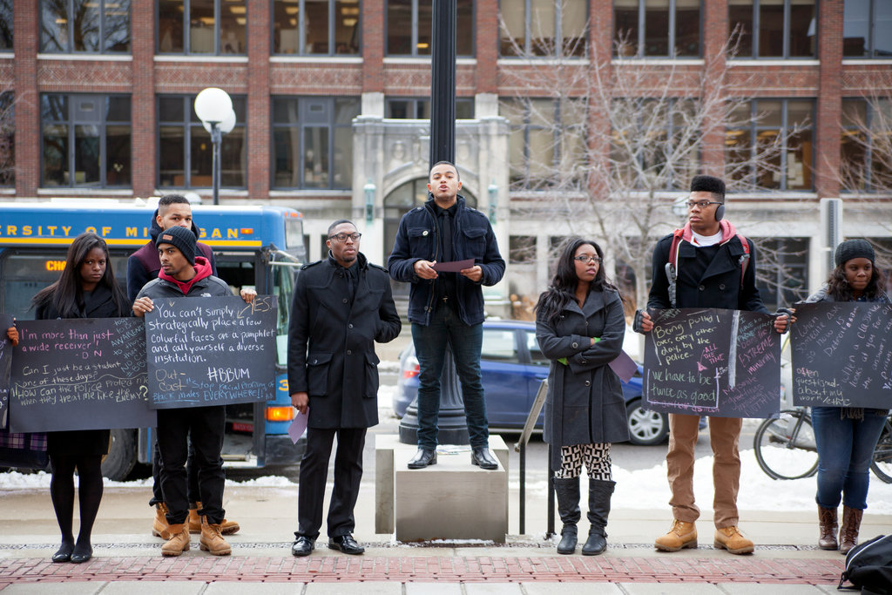
Beyond the immediate provocation of the party, a sharp decline in black undergraduate enrollment — to 4.6 percent of the student body in 2013 from 6.2 percent in 2009 — and a general feeling of isolation among black students on campus have prompted a new wave of student activism, including a social media campaign called “Being Black at the University of Michigan” (or, on Twitter, #BBUM). Members of the university’s Black Student Union have petitioned campus administrators to, among other things, increase enrollment of black students to 10 percent.

Similar episodes and tensions have unsettled colleges including Arizona State; the University of California, Los Angeles; the University of Mississippi; and Dartmouth.
In the news media and in popular culture, the notion persists that millennials — born after the overt racial debates and divisions that shaped their parents’ lives — are growing up in a colorblind society in which interracial friendships and marriages are commonplace and racism is largely a relic.
But interviews with dozens of students, professors and administrators at the University of Michigan and elsewhere indicate that the reality is far more complicated, and that racial tensions are playing out in new ways among young adults
Some experts say the concept of being “postracial” can mean replicating some of the divisions and insensitivity of the past, perhaps more from ignorance than from animus. Others find offensive the idea of a society that strips away deeply personal beliefs surrounding self-identification.
“There’s this preconceived notion that our generation is postracial, but there’s these incidents that happen constantly that disprove that point,” said Zach Fields, a business major here, who is white. He attributed many high-profile incidents — including a number of fraternity parties nationwide that have used racist symbols, including watermelons and gang signs — to ignorance.
“I feel like they don’t mean to be so offensive,” Mr. Fields, 20, said of the party organizers. “It’s not a conscious racism. It’s subconscious.”
Tyrell Collier, 21, the speaker of the Black Student Union, who is majoring in sociology and Afro-American and African studies, said racial tensions on campus had been mounting for months.
“There was a very tense climate brewing all semester, and I think the party was just the peak,” he said. Mr. Collier added that his group, which spearheaded the popular social media campaign, had received inquiries from other black student groups around the country looking to use similar tactics.
“We’re clearly not postracial,” said Tiya A. Miles, chairwoman of the department of Afro-American and African studies. “Sometimes I wonder if having a black president lets people feel like that gives them cover. It absolves people of being prejudiced.”
The number of complaints related to race and ethnicity filed against colleges and universities rose to 860 in 2013 from 555 in 2009, according to the Office for Civil Rights at the federal Education Department. Some experts believe that the increase reflects, at least in part, the role of social media in creating and then publicizing episodes.
Students nationwide responded to a reporter’s request on Facebook and Twitter for stories about racial issues on college campuses. The experiences they described ranged from overt racism to more subtle forms of insensitivity.
Charles Tkacik, a freshman at Johnson & Wales University in North Miami, Fla., who is white, said in an email that while public demonstrations of racism were rare at his university, “there is a deep layer of contempt and hatred among a percentage of students toward other races.”
“Some students believe certain races to be ‘dirty, noisy and rude,’ ” Mr. Tkacik wrote.
Jordan Taylor, a black student at the State University of New York at New Paltz, shared a photo of a “colored only” sign that had been placed on a water fountain in his freshman year.
A black student at Princeton said a racial epithet was once scrawled on his dorm room door. A Korean-American student at the University of Minnesota described being asked by her classmates if she “did massage” or “wore a kimono at home.”
Race is very much an open issue at the University of Michigan. In 2006, Michigan residents voted in favor of Proposition 2, which prohibited affirmative action based on race or ethnicity in admissions and hiring at public institutions. The Supreme Court is expected to rule on the measure this year. These issues are playing out when the minority population is growing nationwide but shrinking on some college campuses.
“I think there is no question that Prop 2 has made it much more challenging for us,” Martha E. Pollack, the university provost and executive vice president for academic affairs, said of the affirmative action vote. “It was difficult to be the kind of community that we wanted to be even when we could use affirmative action.”

Alex Ngo, 21, who is majoring in communications, rejected the notion of colorblindness. “When I hear people say, ‘We’re all people, we’re all human, I don’t see color,’ to me that means, ‘I don’t see you, you don’t exist,’ ” he said. Mr. Ngo, who is Chinese and gay, said he had been subjected to racist and homophobic epithets.
Some students, like James Rice, 21, who is white, see being colorblind as a worthy goal in certain situations. If race is something “not taken into consideration in society in places like education and the workplace, I feel like it’s a really good goal,” Mr. Rice said.
But many others said that failing to account for the reality of race created an unrealistic view of the world.
Gurdit Suri, 19, a finance and international studies major who described himself as a “turban-wearing Sikh,” said he often felt judged by fellow students. “It doesn’t matter how many awards I can get, how many tests I can take, how many times I volunteer,” he said. “I am the other to a lot of people in this campus. People will make judgments about me, implicit or not.”
For many students, racial issues play out as they did for previous generations, as a constant attempt to bridge an often-subtle divide. Nikia Smith, a black freshman, said tensions could be woven into the fabric of daily life — for example, if a white student did not hold a door open for a black student who was about to walk through it. Maybe the student was just in a rush, Ms. Smith, 19, said. But “in my mind, I could be thinking, ‘Oh, it’s because I’m black.’ ”
David J. Leonard, a professor in the department of critical culture, gender and race studies at Washington State University, said young people often viewed racism as something associated with extremist groups like the Ku Klux Klan. “People who don’t see themselves like this think: ‘We can poke fun. We can engage in stereotypes,’ ” Dr. Leonard said. “Racism gets reduced to intent, as if intent is all that matters.”
While black undergraduate enrollment at the University of Michigan has ebbed and flowed over the years, peaking in the 1990s, James J. Duderstadt, a professor of science and engineering who was president of the university from 1988 to 1996, said it was difficult to determine whether racism on campus had, in fact, increased.
He said he believed that the recent spate of activism on diversity was being propelled by two issues: a lack of state funding for public institutions that has led colleges to admit more out-of-state students, who tend to be more affluent and less diverse, and challenges to affirmative action laws in states like Michigan and California.
Some experts say that, rather than being uniformly postracial, young people often see different worlds when they contemplate race — just as their parents did. Blanca E. Vega, a doctoral candidate at Teachers College at Columbia University, who is writing her dissertation on racial conflicts in higher education, said white people tended to see much more progress on race.
“There’s a mismatch in the perceptions of race and racism,” Ms. Vega said, “depending on who you speak with and depending on their racial background.”
A version of this article appears in print on February 25, 2014, on page A1 of the New York edition with the headline: Colorblind Notion Aside, Colleges Grapple With Racial Tension.

