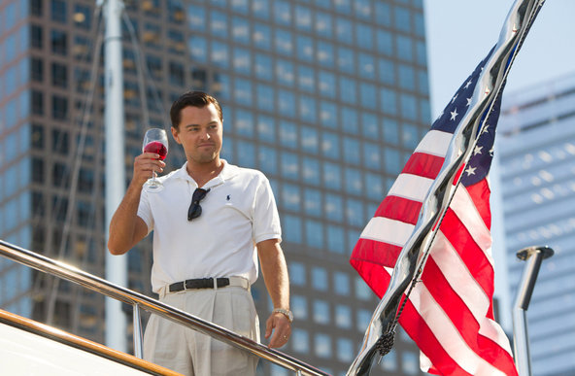
Why Do We Like to Watch Rich People on TV and in the Movies?

By Katherine Schulten
January 23, 2014 5:07 am
A recent Room for Debate post begins, “Several Academy Award contenders like ‘The Wolf of Wall Street’ and ‘American Hustle’ glorify white-collar criminals and scammers, and many reality TV shows embrace the wealthy, too. A new series, ‘#RichKids of Beverly Hills,’ is the latest example of our enthusiasm for ‘ogling the filthy rich.’ Why are we so obsessed with watching the antics of the 1 percent?”
Before you read what the guest writers say, how would you answer that question?
In the Opinion article “Why We Like to Watch Rich People,” four debaters take on this topic. Here are excerpts from each:
Alyssa Rosenberg
America’s fascination with the ill-behaved rich, expressed in both reality television and this year in many movies that are contending for major awards, isn’t limited to the current recession. But the particular incarnation of our fascination seems intended to do something very specific: help us manage our covetousness, at a time when even basic financial security feels out of reach for many people.
Evette Dionne
Black women are a cash cow for cable networks. Millions of us tune in to Bravo, VH1, WE TV and the other networks that have invested in reality television franchises. It is a mutually beneficial relationship. We drive ratings, and in exchange, the networks give us a rare chance to see black women humanized in the media.
Farnoosh Torabi
Long before reality TV, I remember watching the fiercely decorated women of “Dynasty” plot and prance around their big, fancy mansions. Later in my tween and teenage years, my interest turned to soap operas. My favorite: the chic, sun-kissed cast of “Santa Barbara.” Soaps offered an entertaining escape to where budgeting constraints and bad hair days didn’t exist, where we could see how the “rich” lived, and experience — even if just for an hour a day — a part of their fictional lives that seemed vastly more exciting than our own.
Bruce E. Levine
Greed is now normal in our increasingly “money-centric” society, one in which money is at the center of virtually all thoughts, decisions and activities. While money has always been a big deal in America, greed was once seen as the practice of the spiritually sick — such as Mr. Potter from “It’s a Wonderful Life.” But today, greed is seen as both normal and acceptable by the mass media and mainstream politicians.
Students: Read the entire article, then tell us …
- Before you read the responses of the debaters, how did you answer this question? Why do we like to watch rich people?
- With which of the four experts do you most agree? Why?
- Do you agree with Mr. Levine that “greed is now normal” in our society? Do you consider greed to be normal and acceptable? Why?
- Do you know what schadenfreude means? Alyssa Rosenberg contends that we like watching reality shows about rich people, like the “Real Housewives” franchise, because “part of the appeal of those shows is the opportunity to judge their casts” for their bad choices and desperation. Do you agree? Why or why not?
- What movies, shows or books that feature rich people do you most enjoy? Why?
- If you are interested in how money affected one young Wall Street trader, you might also like to read the much-emailed “For the Love of Money.” It begins, “In my last year on Wall Street my bonus was $3.6 million — and I was angry because it wasn’t big enough.” How much money is enough? How much is too much?

