If You Were Governor of Your State, How Would You Spend a Budget Surplus?
By Michael Gonchar
February 4, 2014 5:00 am
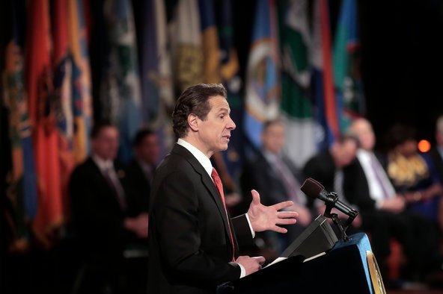
We have become so used to hearing news about layoffs and spending cuts over the past several years that you may not remember what it’s like to have a government surplus — but that’s exactly what’s happening in many states. Politicians now have to figure out what to do with that extra money.
If you were governor of your state, how would you spend a budget surplus?
In the article “Battles Loom in Many States Over What to Do With Budget Surpluses,” Rick Lyman writes:
In a year when three dozen governors are up for election, unexpectedly robust revenues from taxes and other sources are filling most state coffers, creating surpluses not seen in years and prompting statehouse battles over what to do with the money.
After so many years of sluggish revenues, layoffs and draconian service cuts, governors and legislators are eager to use the newfound money to cut taxes, restore spending or, in some cases, pay down debts or replenish rainy-day funds for future recessions. But though revenues are improving, lawmakers are likely to find that there is not enough to pay for everything they want to do, experts say.
“The states are going to have what seems like extra money,” said Scott D. Pattison, executive director of the National Association of State Budget Officers. “Expectations will be high, but the money is not going to be enough to satisfy everyone’s expectations.”
While Republicans are tending to advocate more tax cuts and Democrats are more often pushing to restore spending on education and other programs, the differences between the two camps are not always so stark, with some governors outlining plans that appeal across party lines.
Students: Read the entire article, then tell us…
- If you were governor of your state, how would you spend a budget surplus? What are your priorities?
- Would you want to spend more on education, health care or programs that serve the poor? For example, would you want to reduce class size or keep tuition low at state colleges?
- Would you rather cut taxes so that taxpayers have more money to spend in their communities?
- Or would you recommend putting away money in a rainy-day fund?
- Find your state in the “State of the States.” Do you agree with your governor’s priorities, as summarized in the interactive?

