Who Is Your Family?
By Katherine Schulten
November 27, 2013 5:08 am November 27, 2013 5:08 am

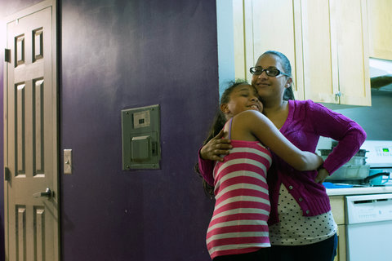
What does “family” mean to you? Do you count only those bound to you by blood or legal ties, or do friends or other kinds of communities also fill some of the traditional role of family for you? How diverse is your family in terms of ethnic, racial, religious, political or other kinds of categories? What role does your family, however you define it, play in your life in general?
As the nation prepares to celebrate Thanksgiving, a new Science Times special feature shows how American households have never been “more diverse, more surprising, more baffling.”
In “The Changing American Family,” Natalie Angier writes an introduction to a special report on the dizzying demographic changes in the American family in recent years:
Kristi and Michael Burns have a lot in common. They love crossword puzzles, football, going to museums and reading five or six books at a time. They describe themselves as mild-mannered introverts who suffer from an array of chronic medical problems. The two share similar marital résumés, too. On their wedding day in 2011, the groom was 43 years old and the bride 39, yet it was marriage No. 3 for both.
Today, their blended family is a sprawling, sometimes uneasy ensemble of two sharp-eyed sons from her two previous husbands, a daughter and son from his second marriage, ex-spouses of varying degrees of involvement, the partners of ex-spouses, the bemused in-laws and a kitten named Agnes that likes to sleep on computer keyboards.
If the Burnses seem atypical as an American nuclear family, how about the Schulte-Waysers, a merry band of two married dads, six kids and two dogs? Or the Indrakrishnans, a successful immigrant couple in Atlanta whose teenage daughter divides her time between prosaic homework and the precision footwork of ancient Hindu dance; the Glusacs of Los Angeles, with their two nearly grown children and their litany of middle-class challenges that seem like minor sagas; Ana Perez and Julian Hill of Harlem, unmarried and just getting by, but with Warren Buffett-size dreams for their three young children; and the alarming number of families with incarcerated parents, a sorry byproduct of America’s status as the world’s leading jailer.
The typical American family, if it ever lived anywhere but on Norman Rockwell’s Thanksgiving canvas, has become as multilayered and full of surprises as a holiday turducken — the all-American seasonal portmanteau of deboned turkey, duck and chicken.
Researchers who study the structure and evolution of the American family express unsullied astonishment at how rapidly the family has changed in recent years, the transformations often exceeding or capsizing those same experts’ predictions of just a few journal articles ago.
“This churning, this turnover in our intimate partnerships is creating complex families on a scale we’ve not seen before,” said Andrew J. Cherlin, a professor of public policy at Johns Hopkins University. “It’s a mistake to think this is the endpoint of enormous change. We are still very much in the midst of it.”
Yet for all the restless shape-shifting of the American family, researchers who comb through census, survey and historical data and conduct field studies of ordinary home life have identified a number of key emerging themes.
Families, they say, are becoming more socially egalitarian over all, even as economic disparities widen. Families are more ethnically, racially, religiously and stylistically diverse than half a generation ago — than even half a year ago.
Students: Read the entire article, then tell us …
- What is the first thought that came to mind on hearing the word “family”? Why?
- How would you describe your family? Does it more closely fit what Ms. Angier describes as the traditional Norman Rockwell depiction (two married parents, of the same race, ethnicity and religion, with children), or is it more like some of the examples she gives of changing families? Why?
- What communities or individuals play a family-like role in your life, even if they’re not connected to you by legal or blood ties? Why?
- Look at the slide show of images readers sent in. Which of those families reminds you of yours? Why?
- Overall, what role does your family, however you define it, play in your life?

